NET512

Designing and Implementing a Secure, Scalable, and Automated

Enterprise Network

Weekly Practical Plan - NQF Level 5 | 17 Credits
  - Week 10: DHCP Configuration (5 Marks)
Tasks:
Cisco DHCP Client
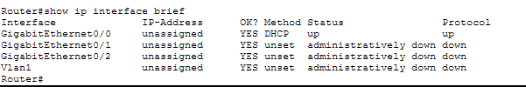
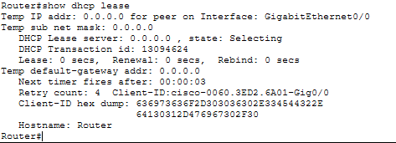
Cisco DHCP Server
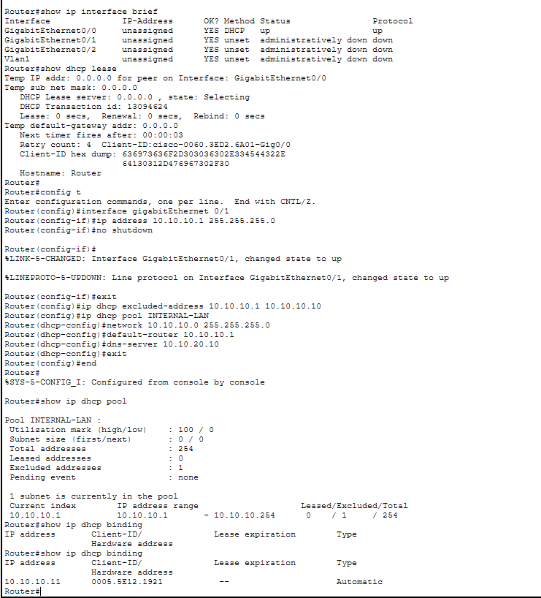
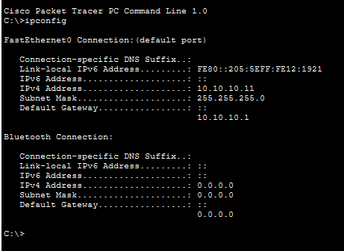
External DHCP Server
